# Lab Manual 2

**Study of different types of Network Devices and Network cables and practically implement the cross-wired cable and straight through cable using clamping tool CLO 1**

**Objectives:**

Study of following Network Devices in Detail

* + Repeater
  + Hub
  + Switch
  + Bridge
  + Router
  + Gate Way

1. Study of different types of Network cables and Practically implement the cross-wired cable and straight through cable using clamping tool.

## **Network devices:**

1. **Repeater:** Functioning at Physical Layer. A repeater is an electronic device that receives a signal and retransmits it at a higher level and/or higher power, or onto the other side of an obstruction, so that the signal can cover longer distances.

Repeater have two ports, so cannot be used to connect for more than two devices

1. **Hub:** An Ethernet hub, active hub, network hub, repeater hub, hub or concentrator is a device for connecting multiple twisted pair or fiber optic Ethernet devices together and making them act as a single network segment. Hubs work at the physical layer (layer 1) of the OSI model. The device is a form of multiport repeater. Repeater hubs also participate in collision detection, forwarding a jam signal to all ports if it detects a collision.
2. **Switch:** A network switch or switching hub is a computer networking device that connects network segments. The term commonly refers to a network bridge that processes and routes data at the data link layer (layer 2) of the OSI model. Switches that additionally process data at the network layer (layer 3 and above) are often referred to as Layer 3 switches or multilayer switches.
3. **Bridge:** A network bridge connects multiple network segments at the data link layer (Layer 2) of the OSI model. In Ethernet networks, the term bridge formally means a device that behaves according to the IEEE 802.1D standard. A bridge and switch are very much alike; a switch being a bridge with numerous ports. Switch or Layer 2 switch is often used interchangeably with bridge Bridges can analyze incoming data packets to determine if the bridge is able to send the given packet to another segment of the network.
4. **Router:** A router is an electronic device that interconnects two or more computer networks and selectively interchanges packets of data between them. Each data packet contains address information that a router can use to determine if the source and destination are on the same network, or if the data packet must be transferred from one network to another. Where multiple routers are used in a large collection of interconnected networks, the routers exchange information about target system addresses, so that each router can build up a table showing the preferred paths between any two systems on the interconnected networks.
5. **Gate Way:** In a communications network, a network node equipped for interfacing with another network that uses different protocols.

* A gateway may contain devices such as protocol translators, impedance matching devices, rate converters, fault isolators, or signal translators as necessary to provide system interoperability. It also requires the establishment of mutually acceptable administrative procedures between both networks.
* A protocol translation/mapping gateway interconnects networks with different network protocol technologies by performing the required protocol conversions

## **Coding standards**

**What is 568?**

ANSI/TIA-568 is a set of telecommunication standards from the Telecommunication Industry Association (TIA). The standard address commercial building cabling for telecommunication products and services.

TIA defines two different separate pin outs 568A and 568B for any eight conductor twisted pair cabling. 568A is recommended for most cabling systems and 568B as an alternative to accommodate certain cable systems.

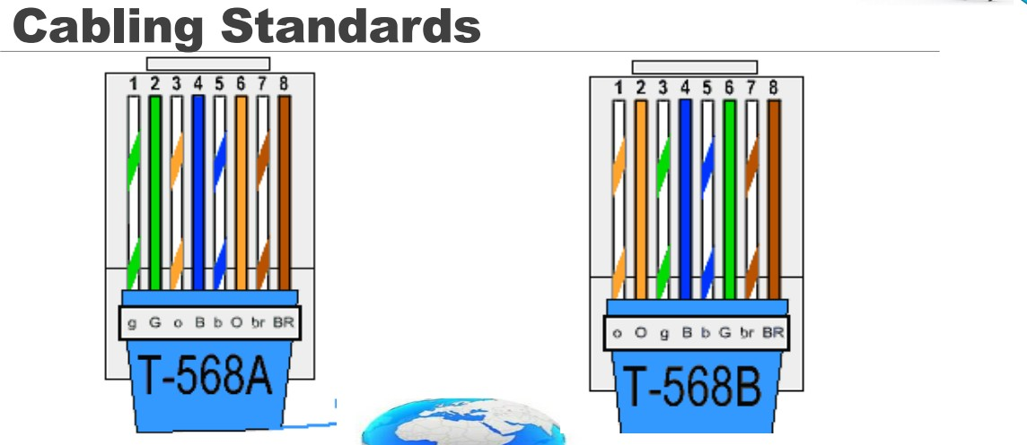

**Cabling Types:**

There are three types of cables:

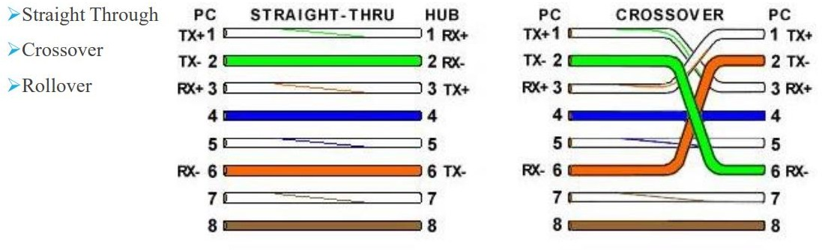

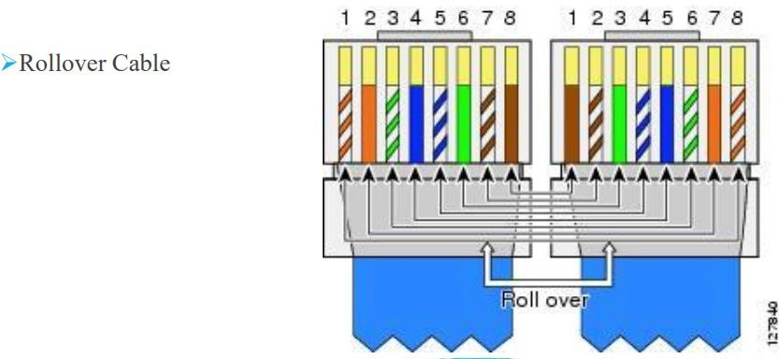

**Straight Through Cross-over Rollover**

|  |  |  |  |  |  |
| --- | --- | --- | --- | --- | --- |
| 1 | 1 | 1 | 1 | 1 | 8 |
| 2 | 2 | 2 | 2 | 2 | 7 |
| 3 | 3 | 3 | 3 | 3 | 6 |
| 4 | 4 | 4 | 4 | 4 | 5 |
| 5 | 5 | 5 | 5 | 5 | 4 |
| 6 | 6 | 6 | 6 | 6 | 3 |
| 7 | 7 | 7 | 7 | 7 | 2 |
| 8 | 8 | 8 | 8 | 8 | 1 |

**Crimping Tool**

A crimping tool is a device used to conjoin two pieces of metal by deforming one or both of them in a way that causes them to hold each other. The result of the tool's work is called a crimp. A good example of crimping is the process of affixing a connector to the end of a cable.

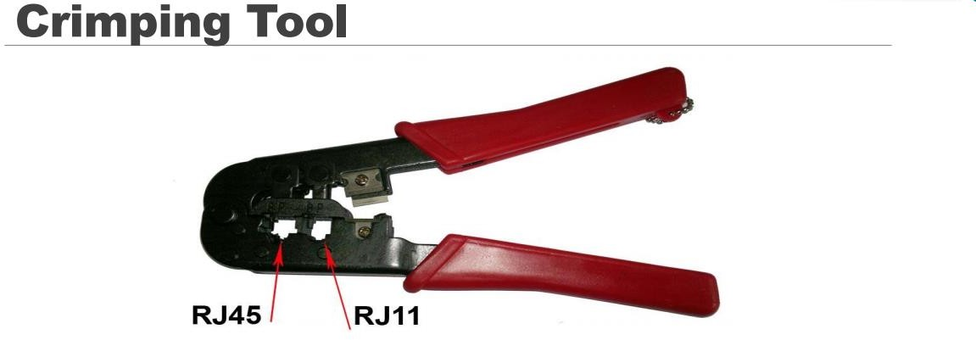

Cable Tester:

